**MERN Logo Creation Platform: Step-by-Step Project Plan**

This guide breaks down the development of your logo creation platform into sequential phases based on your flowchart. Following these steps will ensure you build the application logically, with a solid foundation.

**Phase 0: Foundation & Setup (The Groundwork)**

**Goal:** Prepare your development environment, project structure, and basic server.

1. **Prerequisites:**
   * Install [Node.js](https://nodejs.org/) (which includes npm).
   * Install [MongoDB Community Server](https://www.mongodb.com/try/download/community) or set up a free cluster on [MongoDB Atlas](https://www.mongodb.com/cloud/atlas/register).
   * Install a code editor like [VS Code](https://code.visualstudio.com/).
2. **Project Structure:**
   * Create a main project folder (e.g., logo-creator).
   * Inside it, create two subfolders: server for your backend and client for your React frontend.
3. **Backend Setup (in the server folder):**
   * Initialize a Node.js project: npm init -y
   * Install core dependencies: npm install express mongoose cors dotenv
   * Install authentication dependencies: npm install bcryptjs jsonwebtoken
   * Install dev dependency for auto-restarting the server: npm install -D nodemon
   * Create a basic Express server file (index.js) that listens on a port (e.g., 5001).
   * Set up your MongoDB connection using Mongoose.
4. **Frontend Setup (in the client folder):**
   * Create a new React app: npx create-react-app .
   * Install frontend dependencies: npm install fabric axios react-router-dom

**Phase 1: Backend Core - API & Authentication**

**Goal:** Build the API endpoints for user management and saving/loading projects.

1. **User Authentication:**
   * **Model:** Create a User model with Mongoose (fields: name, email, password).
   * **Routes:** Create an auth.js routes file with endpoints for /api/auth/register and /api/auth/login.
   * **Logic:**
     + For registration, hash the user's password with bcryptjs before saving it to the database.
     + For login, compare the provided password with the stored hash. If it matches, generate a JSON Web Token (JWT).
   * **Middleware:** Create a middleware function that verifies the JWT from the request headers to protect certain routes.
2. **Project API (CRUD):**
   * **Model:** Create a Project model with Mongoose (fields: user (to link to the User model), projectName, canvasJSON (Type: String)).
   * **Routes:** Create a projects.js routes file with the following endpoints. **Protect all of them with your JWT middleware.**
     + POST /api/projects: To save a new project. It will receive the canvas JSON in the request body.
     + GET /api/projects: To get all projects for the logged-in user.
     + GET /api/projects/:id: To get a single project's data.
     + PUT /api/projects/:id: To update an existing project.
     + DELETE /api/projects/:id: To delete a project.

**Phase 2: Frontend Core - UI & Canvas Editor**

**Goal:** Build the user-facing part of the application, including the main logo editor.

1. **Routing & Pages:**
   * Use react-router-dom to set up routes for Login, Register, a Dashboard, and the Editor page.
2. **Authentication UI:**
   * Create Login and Register components with forms.
   * When a user logs in successfully, save the received JWT to localStorage and use a state management solution (like React Context) to manage the user's authentication state globally.
3. **Dashboard Page:**
   * This page should be protected (redirect to login if not authenticated).
   * On page load, make an API call to GET /api/projects to fetch and display a list of the user's saved projects.
   * Include a "Create New Project" button that navigates to the Editor page.
4. **Editor Page - The Canvas:**
   * Create a new component for your editor.
   * In a useEffect hook, initialize a new Fabric.js canvas on a <canvas> element.
   * **Create UI Controls:**
     + Buttons to add basic elements (Text, Circle, Rectangle) to the canvas.
     + Input fields to change the properties (color, font size, stroke, etc.) of the currently selected object on the canvas. You'll need to use Fabric.js event listeners like object:selected to know what to edit.

**Phase 3: Connecting Frontend & Backend (Integration)**

**Goal:** Make the frontend and backend talk to each other to save and load designs.

1. **Saving a Project:**
   * In your Editor UI, add a "Save" button.
   * When clicked, serialize the canvas content into a JSON object using canvas.toJSON().
   * Send this JSON data in a POST (for new projects) or PUT (for existing projects) request to your /api/projects endpoint using axios.
2. **Loading a Project:**
   * On the Dashboard, when a user clicks on a saved project, navigate them to the editor page with the project's ID in the URL (e.g., /editor/12345).
   * In the Editor component, grab the project ID from the URL.
   * In a useEffect hook, make a GET request to /api/projects/:id.
   * Use the canvasJSON from the response to load the design onto the canvas using canvas.loadFromJSON(data.canvasJSON, ...)

**Phase 4: Advanced Features - Exporting**

**Goal:** Implement the PNG and SVG export functionality as shown in the flowchart.

1. **Frontend Export Buttons:**
   * Add "Export SVG" and "Export PNG" buttons to your Editor UI.
   * When clicked, these buttons will also serialize the canvas to JSON (canvas.toJSON()).
2. **Backend Export Endpoints:**
   * You'll likely need a server-side canvas library. fabric.js has a version for Node.js (npm install fabric).
   * **SVG Export (POST /api/export/svg):**
     + This endpoint receives the canvas JSON.
     + It loads this JSON into a server-side Fabric canvas instance.
     + It calls the .toSVG() method.
     + It sends the resulting SVG string back to the client with the correct headers to trigger a file download.
   * **PNG Export (POST /api/export/png):**
     + This is similar but more complex. The endpoint receives the canvas JSON.
     + It loads the JSON into a server-side Fabric canvas.
     + It generates a PNG data stream from the canvas.
     + It sends this data stream back to the client as a downloadable file.
3. **Frontend Download Logic:**
   * The frontend receives the file data from the API and uses JavaScript to create a temporary link (<a> tag) and programmatically click it to trigger the user's browser download prompt.

**Phase 5: Refinement & Deployment**

**Goal:** Polish the application and make it publicly available.

1. **Styling & UX:**
   * Use a CSS framework (like Tailwind CSS or Material-UI) to make the application look professional.
   * Add loading indicators for API calls and user feedback for actions (e.g., "Project Saved!").
   * Ensure the application is responsive and works on different screen sizes.
2. **Error Handling:**
   * Implement robust error handling on both the frontend (e.g., failed API calls) and backend.
3. **Deployment:**
   * **Backend:** Deploy your Node.js server to a platform like **Heroku**, **Render**, or a cloud provider (AWS, Google Cloud).
   * **Frontend:** Deploy your React app to a static hosting provider like **Netlify** or **Vercel**.
   * **Configuration:** Make sure to configure environment variables (like your database connection string and JWT secret) on your deployment platform.

**Backend Folder Structure (server)**

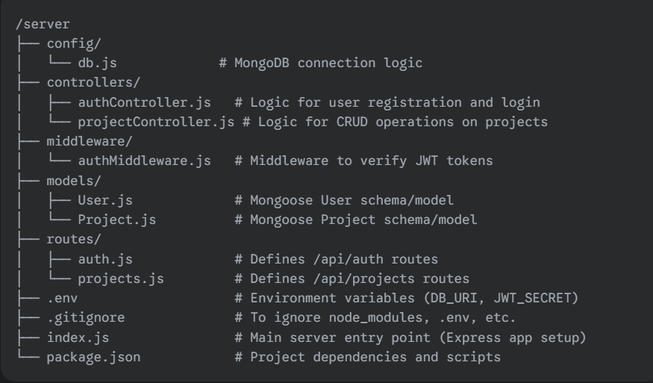

**Explanation:**

* **config/:** Holds configuration files, like your database connection.
* **controllers/:** Contains the business logic for your API. Routes will call functions from these files.
* **middleware/:** For functions that run between the request and the response, perfect for authentication checks.
* **models/:** Defines the data structure (schemas) for your MongoDB collections.
* **routes/:** Defines the API endpoints and connects them to the controller functions.
* **.env:** Stores sensitive information like database credentials and secrets.
* **index.js:** The main file that initializes your Express server and ties everything together.

**Frontend Folder Structure (client)**

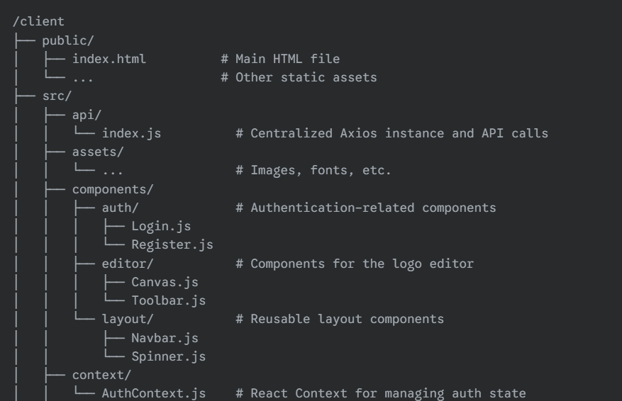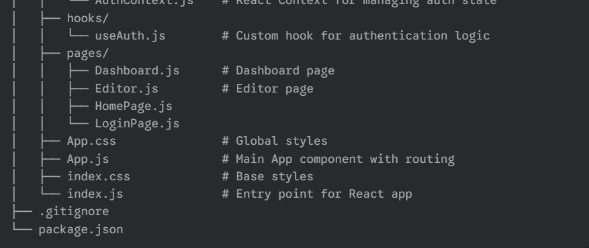

**Explanation:**

* **api/:** A great place to keep all your axios or fetch calls organized, so you're not scattering them inside components.
* **assets/:** For static files like images, SVGs, and custom fonts.
* **components/:** For reusable UI pieces. They are often organized by feature (e.g., auth, editor).
* **context/:** For managing global state with React's Context API (e.g., keeping track of whether a user is logged in).
* **hooks/:** For custom React hooks to reuse component logic**.**
* **pages/:** For top-level components that represent a full page or view, which you'll link to with React Router.
* **App.js:** The root component where you will likely define your application's routing structure.